UNICEF Marketplace

Price Analysis Prototype

# Abstract

UNICEF Marketplace is a system for physical aching and selling of goods in low-resource settings in developing markets. A system like this could be used where transportation between nodes can be difficult. Herein we refer to locales (nodes etc) as Regions.

A model of this system at large might look something like this:

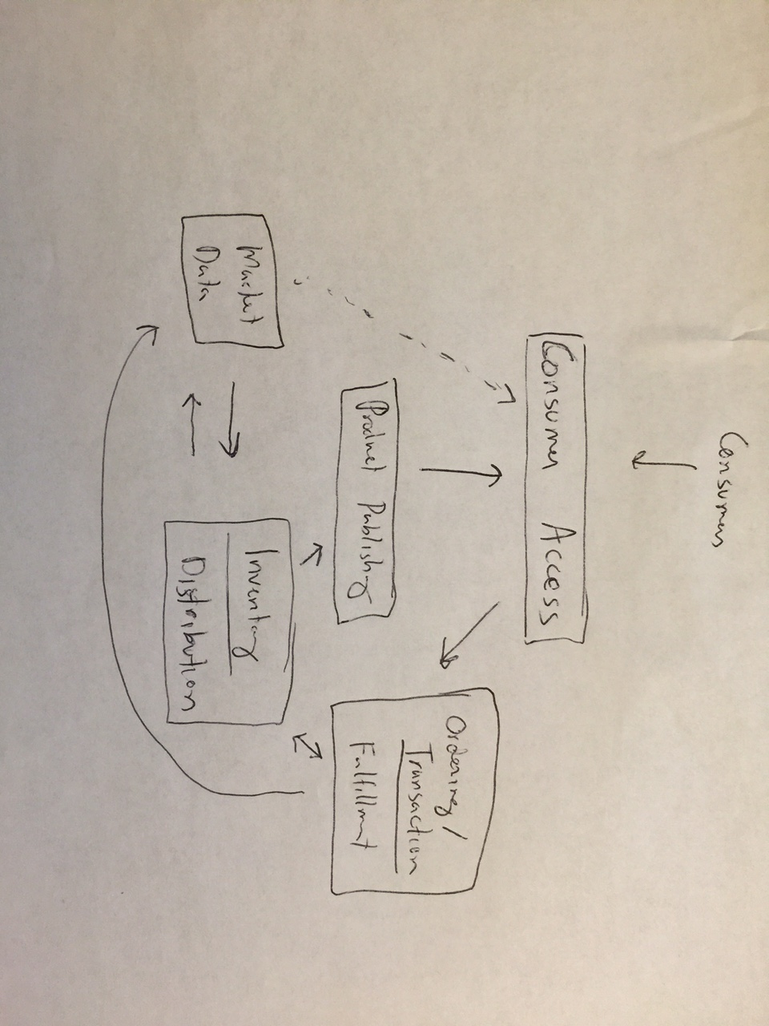

**This prototype will focus on the ‘market data’ facility, making pricing suggestions for products in regions based on live market data and will be used by sellers.**

A basic Product Order model will contain price paid for orders of a product in a specific region. This data will be analyzed, and price suggestions will be made using the five day moving average price for that product in that region. Price suggestions are inspired by simple stock trading techniques which use past moving averages of price and demand to forecast future price. We also take into consideration events which may impact the regional economy, as well as short term surges in demand.

# Purpose and Vision

A fully featured system would make price suggestions based on inventory price, and have high locale fidelity. There would be API endpoints to receive regional events, and API endpoints to make market data available. This module would integrate tightly with an ordering/transaction module, and an inventory/distribution model.

# How to Use

Access the application at <http://54.174.101.53/>

On the home page, there are links to Orders, Products, Events, and Regions. These are self-explanatory.

The main area is Regions. This is pre-populated with regions in Iran. If you click on a region, you will see products. If you click on a product, you will see analysis of that product’s price:

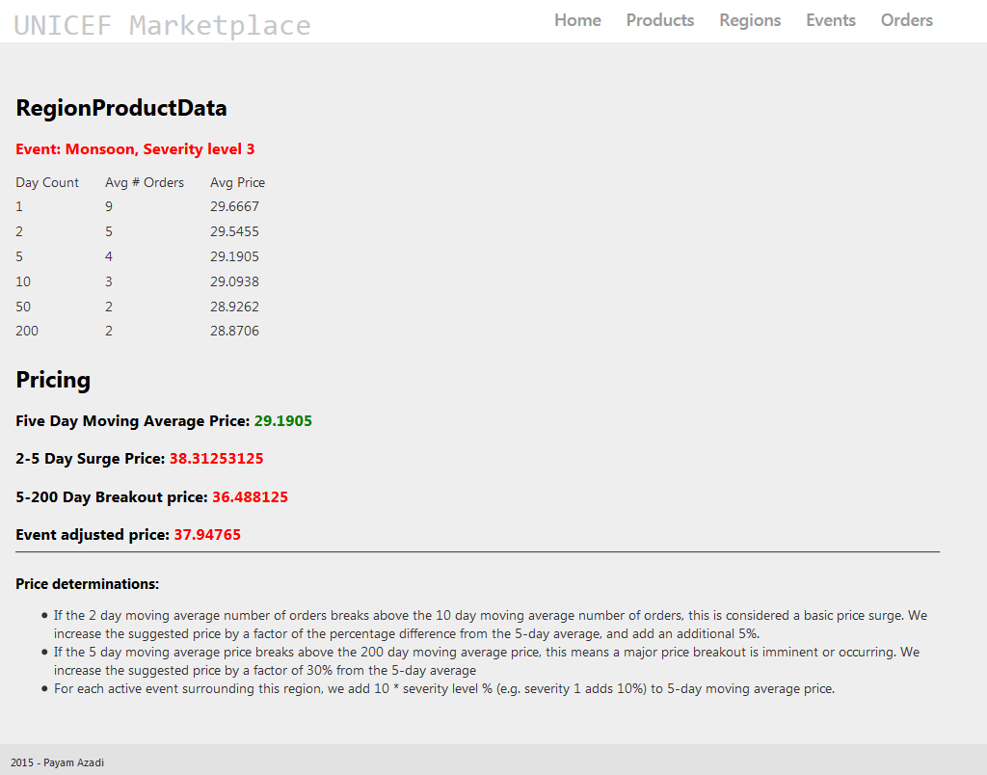

**A script was made to populate the Orders system with dummy orders for each product. However product data is available only for Gilan.**

# Caveats, Assumptions, Requirements

* This system will be used by sellers/distributors.
* Supply-side data will not be considered or implemented anywhere – focus is analyzing demand based on market orders only.
* Will implement a simple event model.
* Will implement a simple region model.
* Will implement a simple product system.
* Will implement a basic order model. An order will contain an entered date, fulfilled date, price, product, and region.
* All else held equal, a surge in demand will indicate a need to increase price. Separately, a major event will indicate a future price increase. It’s hard to say whether a surge in demand is a result of a major event, and to what extent so. We will provide up to four prices:
  + Five day moving average price. This is our baseline.
  + A surge in demand ( two day moving average number of orders exceeds five day moving average number of orders by at least 15%) will result in a price projection that takes the five-day moving average price, increases it by the percentage increase in order volume, and adds an additional 5%.
  + If the 5 day moving average price exceeds the 200 day moving average price, a price “breakout” is imminent or occurring. Stock trading forecasts breakouts when a short term moving average begins to exceed the 200 day moving average.
  + We project price as the 5-day moving average price + 30%.
  + Project a price surge based on active events, grounded on 5 day moving average, adding to price by a factor based on event severity (.1 * severity %, e.g. severity 1 event results in a 10% price increase).
* Calculation of moving average ignores the fact that there may be no orders on particular days. If last week there were orders everyday but this week there were no orders at all, the 14 day moving average numbers would be the same as last week’s average.